Fuck You

Train Themed Food Cart
Ella Fyock, Lucas Jorgenson, and Gregory Tenner
MEET Department, SUNY Alfred State College of Technology
MECH 3223: Mechanical Design Principles
Professor Aric Bryant
October 16, 2026

Introduction
Transportation has evolved over many centuries. People first traveled everywhere on foot. Creating carriages for animals to pull allowed them to travel farther and faster. Boats allowed for the transport of people and goods over long distances and enabled international trade, as well as the start of industrialization. The invention of the train, however, was perhaps the most influential of all. It allows for fast and efficient transport from one end of a country to the other. It was the backbone on which modern industries were built, a catalyst of western expansion, and a vital part of major cities. Trains were especially important in New York since they not only allowed the transport of people to, from, and around New York City, but also the transport of goods to and from major industrial centers such as Buffalo and Rochester. From 1820 to 1900, the railroad system helped the population of the state grow from 1.4 million people to almost 11 million people (Department of Transportation). Large and small cities as well as rural areas were connected by railroads. Connecting these communities allowed ideas and products to be exchanged and helped people move throughout the state. Foodstuffs and raw material were brought towards the cities while manufactured goods and summer vacationers were brought out to the country (Department of transportation). This exchange of goods helped the economy grow and promoted industrialization. Trains are beloved by many for these reasons, as well as for their interesting appearance. While diesel and electric trains have sleek, modern designs, the exposed mechanical workings of historical steam locomotives led us to choose the pre-1920s era of train designs for our food display cart. Many passenger train cars during this time were designed on the Pullam train cars. George Pullan first improved upon the sleeping cars in 1867 and created his company, Pullman Palace Car Company (U.S. Department of the Interior.). His company became known for the luxury and comfort they provided in their train cars. The Pullman company produced and designed many train cars including observation cars, dining cars, parlor cars, and their famous sleeper cars (U.S. Department of the Interior.). The focus of these cars was on the passengers and giving them the best experience. The inside of the cars had plush seating, detailed woodwork and brass fixtures to create an atmosphere in which the customer felt elite in (U.S. Department of the Interior.). The company also provided trained service workers including maids, attendants, dining staff and more. This provided passengers with great hospitality and quality while traveling (U.S. Department of the Interior.). The efficiency of these trains depended on the crew that was running them. Their skills, coordination, and communication were put to the test every journey. The Railway Safety Appliance Act of 1893 required automobile knuckle couplers with automated air brakes on railways cars in interstate travel and in 1903 the government pushed this regulation to be employed faster (Burns). Railroad workers were responsible for connecting the train carts where they had to physically position the links and insert the pins between moving cars, which was extremely dangerous. They also had to help stop the trains and manage brakes. The Hours-of-Service Act in 1907 continued to look after the workers and placed a limit on how long they could work (Burns). These measures demonstrated that the government began imposing safety standards on the train companies as trains became more popular and the standard way of travel.
Design Decisions
The three moving elements in our design are decorative rotating train wheels, a waving driver, and a 2-tier rotating dessert display. The train wheels will use V belt drive systems which allow us to select a large range of rpm input and output values, as well as position the motor in a better location. The motors only need to have around 0.125 HP since the wheels will be on bearings and should not provide much resistance to motion. This is also true for the motor powering the waving driver shown in Figure 4, which is also purely decorative. In addition to a V belt drive, the driver mechanism will also need mechanical linkages, such as those shown in Figure 5, to create a back-and-forth waving motion. The two-tier rotating dessert display will utilize a gear drive mechanism since it needs to be compact to be contained inside the exhaust column. The motor will also need to have slightly more power, around 0.25 HP to be able to move desserts of various weights, as well as handle higher and asymmetric loads when desserts are picked up or placed down. To keep the cart portable, we will power the motors using 12 V lithium batteries, which can be charged between uses. The requirement that the carts be easily stored provides challenges for the design of the mechanical systems. Our solution is to use foldable carts which fold vertically in half as shown in Figure 1. In choosing to purchase a cart instead of making our own, we are limited by the dimensions that the company gives us and by the weight the cart can hold. To make the carts look like a train, we will create four decorative sides that will attach to each cart using hooks and magnets, making them easy to assemble and disassemble. The decorative sides will be narrow and easy to store. Since the carts fold in half, there will be no room to attach motors, gears, or pulleys. They will instead attach to the decorative sides which are conceptualized in Figure 6. To keep weight down, the sides will be made with sheets of plastic with high strength and low weight. These decisions have been made to accurately represent the trains that shaped our world and showcase their unique, interesting features as well as being feasible and accessible.
Initial Design Concept
The initial design concept that we came up with is to have two carts which can be pushed around or stationary. One will be designed as a vintage locomotive and the other as a passenger train car. We can purchase a wheeled, three-tiered cart, as shown in Figure 1, that folds up and can be locked in place. After buying these carts we can attach plastic cutouts of the locomotive and the passenger car. The plastic cutouts will be attached using strong magnets that are glued on and with hooks that attach to the edge of the prepurchase cart for easy removability and storage. There will be decorative train wheels securely attached to the plastic cutouts on the bottom tier of both carts that move to simulate train movement. The open space on the bottom tiers will be covered by plastic cutouts, hiding the motor and belt drive systems. On the top of the locomotive cart, there will be a two-tier rotating dessert display decorated as the exhaust of the train and a steam dome that can hold desserts on top of it. One side of the cart’s handles must be cut off and the opening covers to make room for the exhaust. There will also be a silhouette of a conductor waving their hand in the cab window. Also, as decoration, the front of the locomotive will have a smoke door and a cow catcher. The passenger cart has cut-out windows for desserts to be displayed for easier access for children or for those with disabilities such as arthritis who may have difficulty reaching desserts higher up. Overall, the design will combine the historical appearance of passenger trains with the practical needs if a modern dessert cart.
Standards, Codes, and Regulations
There are many regulations we must comply with to ensure the safety of everyone who interacts with the carts. These regulations mostly come from the Occupational Safety and Health Administration (OSHA), which is responsible for ensuring the safety of workers. Regulation standard 1910.212 requires guarding to be provided to protect the operator and other hazards, such as a high-speed belt. Our mechanisms will be safely enclosed so that no dangerous moving parts are exposed. To comply with standard 1910.303, which outlines requirements for electrical components, we will include fuses for overcurrent protection. All wires will be properly installed and marked. We will also use strong fasteners to secure electrical components, as required by standard 1926.403. Standard 1926.959 requires that employees cannot be exposed to high electrical voltages, which we will guarantee by enclosing electrical components in insulated boxes and wires, as well as by including warning labels. The wheels on each cart include locking mechanisms to comply with standard 1926.600 (U.S. Department of Labor). An important safety feature most machines must have is an emergency stop button. The National Fire Protection Association specifies in NFPA code 79 that emergency stop buttons must always be operable, readily accessible, and initiated with a single human action via a mechanical latching mechanism (Morris, 2026). We will of course include an emergency stop button that matches these criteria. In case of a fire, such as one started by a belt continuously rubbing on a flammable material, we will also include a portable fire extinguisher. NFPA 10 outlines the requirements for portable fire extinguishers. A potential danger causing component of our carts is the batteries. To mitigate these dangers, we will use UL 1642 certified batteries which have been tested to meet certain safety requirements. All these regulations are important to make the food carts as safe as possible for everyone who interacts with them.
Disability
The disability we chose to accommodate in our design is arthritis. Arthritis is when there is joint inflammation but is more accurately described as a disorder in which the smooth cartilaginous layer that lines a joint is lost, resulting in bone grinding on bone during joint movement. This almost always results in pain and stiffness around that joint. Other symptoms can include redness, swelling, and reduced range of motion (U.S. Department of Health and Human Services, 2025). These symptoms make simple everyday actions difficult for those affected. There are over 58 million people diagnosed with arthritis in the US, around half of whom report activity limitations due to arthritis (Centers for Disease Control and Prevention, 2024). There are possibly millions more cases that are undiagnosed. To accommodate this disability, we will design spots where the desserts can be placed lower to the ground. This will make it easier for people in wheelchairs to grab desserts, since they cannot stand up to reach the desserts on the top of the cart. It will also make it easier for people with pain in their arms and shoulders to grab desserts, since they will not have to reach as high. This reduced range of motion is often more comfortable for people with shoulder pain. Since some desserts may be too heavy for some people with arthritic hands to comfortably lift with one hand, the dessert windows will be made large enough to accommodate grabbing with two hands. The desserts on this level will also be stationary, since movement would make them especially difficult to grab for those with arthritis.
References
Burns, A. (2026). Railroads in the 1900s (1900–1910): Facts, statistics, history. American Rails. https://www.american-rails.com/1900s.html
Centers for Disease Control and Prevention. (2024, June 3). Arthritis. Centers for Disease Control and Prevention. https://www.cdc.gov/cdi/indicator-definitions/arthritis.html
Department of Transportation. (n.d.). Passenger Rail Service in New York State. New York State Department of Transportation. https://www.dot.ny.gov/divisions/operating/opdm/passenger-rail/passenger-rail-service/history-railroads
Morris, B. (2026, February 3). NFPA 79 & OSHA emergency stop requirements with checklist. constructandcommission. https://constructandcommission.com/emergency-push-button-requirements
Publications International Ltd. (n.d.). Early twentieth century railroads. howstuffworks. https://history.howstuffworks.com/american-history/early-twentieth-century-railroads.htm
The evolution of travel on passenger trains - strasburg railroad: Train rides in Lancaster Country, PA. Strasburg Railroad | Train Rides In Lancaster Country, PA. (2022, October 4). https://strasburgrailroad.com/evolution-of-passenger-trains/
U.S. Department of Health and Human Services. (2025, July 1). Arthritis. National Institute of Arthritis and Musculoskeletal and Skin Diseases. https://www.niams.nih.gov/health-topics/arthritis
U.S. Department of Labor. (n.d.). Regulations (Standards - 29 CFR). Occupational Safety and Health Administration. https://www.osha.gov/laws-regs/regulations/standardnumber
U.S. Department of the Interior. (2023). The Pullman Car Shops. National Parks Service. https://home.nps.gov/pull/learn/historyculture/the-pullman-car-shops.htm?
Vevor. (n.d.). Vevor 3 shelf utility cart. https://www.vevor.com/utility-cart-c_12560/vevor-foldable-utility-service-cart-3-shelf-165lbs-heavy-duty-plastic-rolling-cart-with-lockable-wheels-ergonomic-handle-portable-garage-tool-cart-for-warehouse-office-home-25-62-x15-43-x32-76--p_010804567519

Appendix
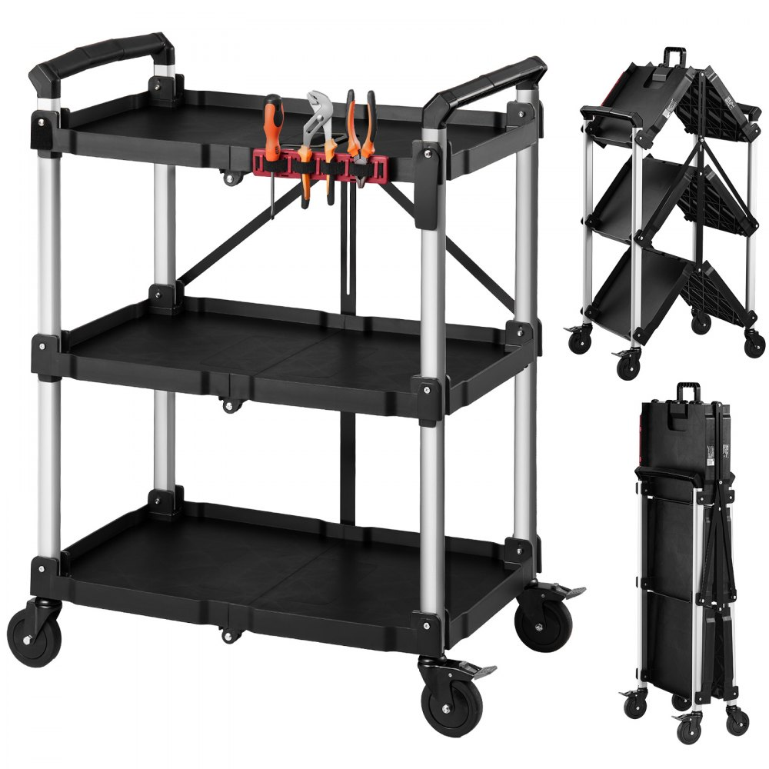
Figure 1 – Foldable Utility Cart

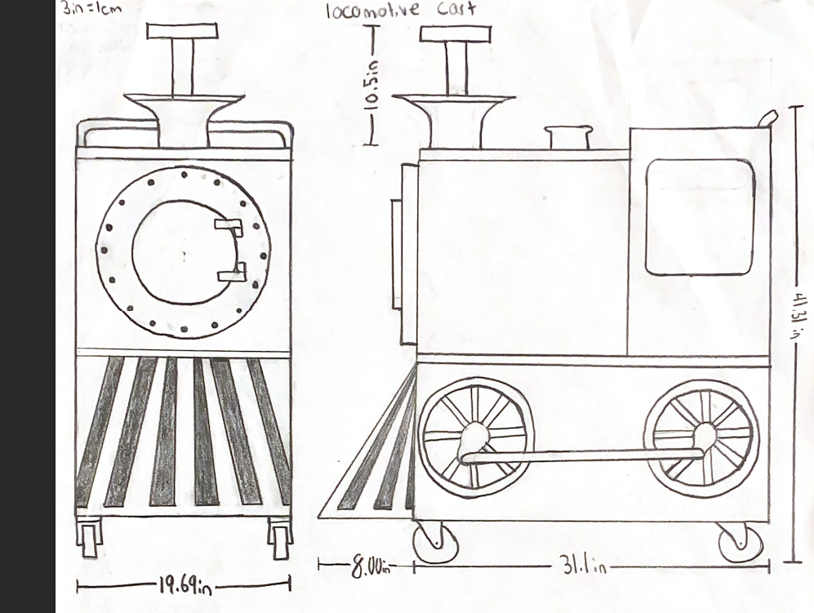
Figure 2 – Initial Locomotive Design Visualization
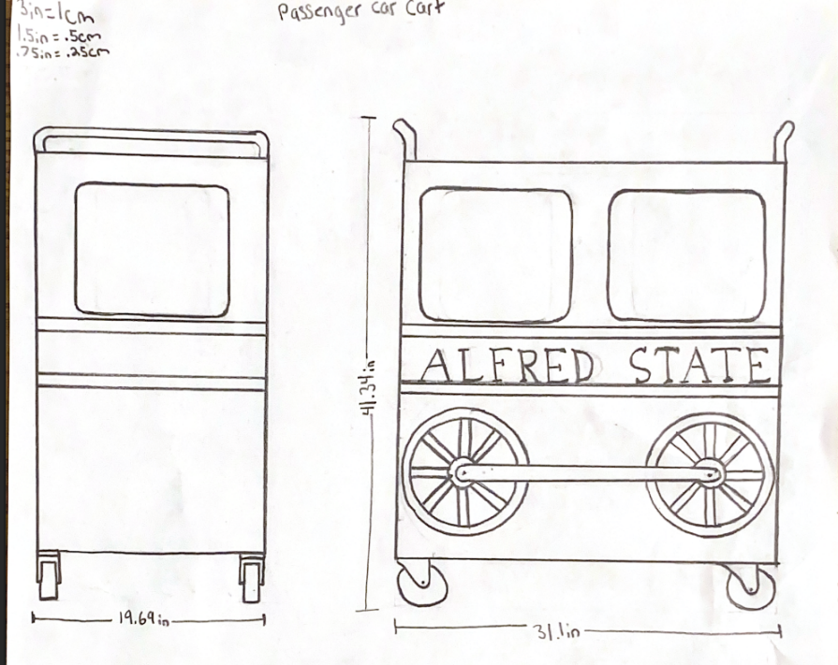
Figure 3 – Initial Passenger Cart Design Visualization
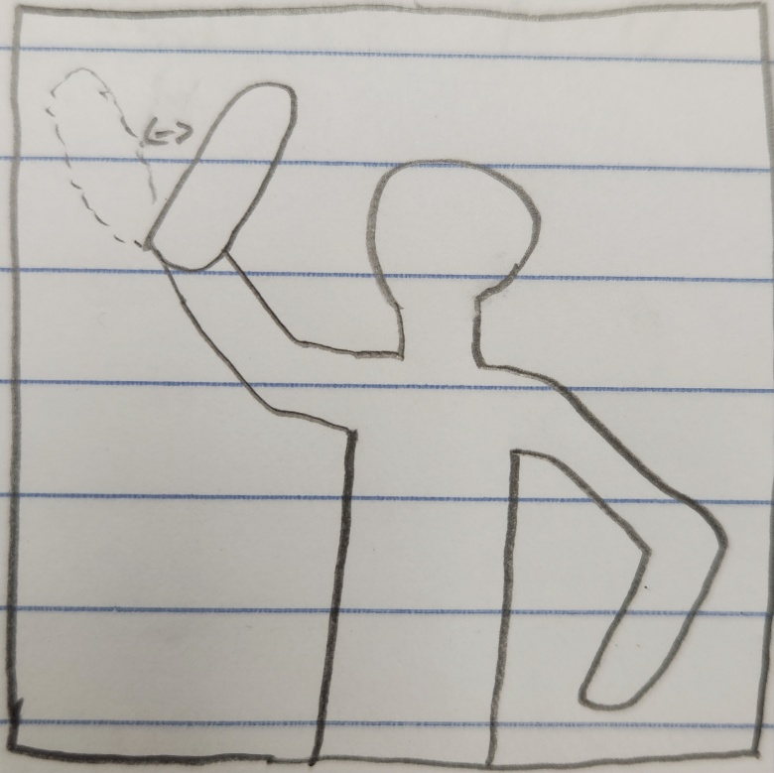
Figure 4 – Waving Driver Concept Drawing

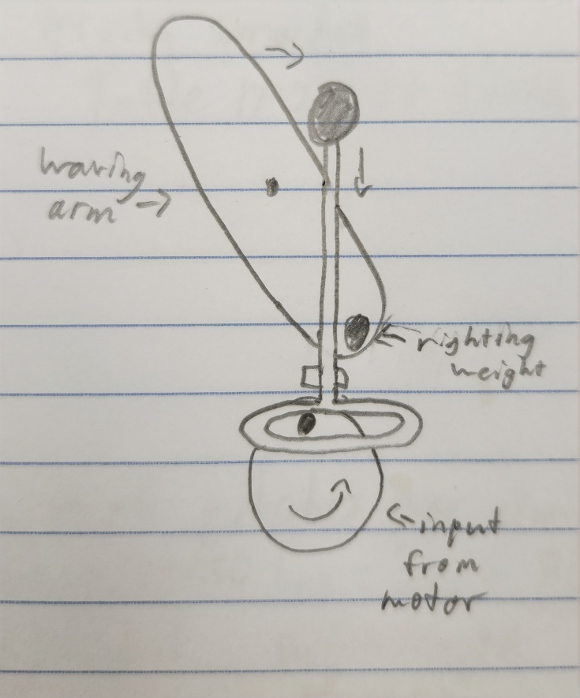
Figure 5 – Driver Waving Mechanism Concept
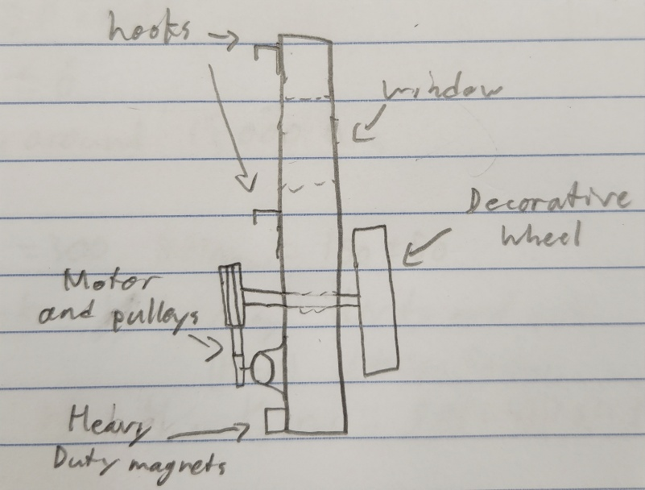
Figure 6 – Passenger Cart Side Cutout Concept

